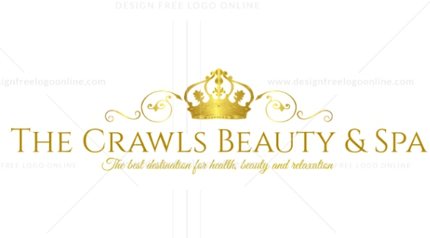
Business Name: THE CRAWLS BEAUTY & SPA
Address: 1922 Cedar St, Mackenzie, TN 38201
Phone Number: 731-345-1123
Owners: Erick Johnson and Allison Parker

Table of Contents
Executive Summary 3
Vision and Mission 5
Company Overview…………………………………………………………………………….5
Product/ Service Strategy…………………….………………………………………………….7
Market Analysis ……………………………………………………….………………………7
Marketing Plan ………………………………………………………………………………….8
Financial Plan ………………………………………………………………………………….8
Supporting Document ……………………………………………………………………….11

EXECUTIVE SUMMARY
One of the major problems facing residents in Cedar Street, Mackenzie Tennessee is the inability to access dependable beauty and spa destinations, where they can enjoy quality health, rejuvenation, beauty, and relaxation services. Although the industry has grown significantly in the area, there is still the lack of provision of diverse services to diverse populations. This challenge prompts actors in the business world to craft viable business strategies and start a business that can address residents’ needs and at the same time improve their wellbeing. The Crawls Beauty & Spa was founded to help address the problem and generally improve the lifestyles of people in Mackenzie and beyond.
The business is located in 1922 Cedar Street, Mackenzie, TN 38201. Clients can make appointments by calling the company phone, 856-345-1123. This is a highly competitive place with competitors like Elevations Salon and Day Spa, A Cut Above, and Edge Hair Design Studio. The success of these businesses in the area is an indication of growth and potentially large market. Cedar Street has attracted a large number of businesses in different industries, transforming the area into an urban destination.
The Crawls Beauty & Spa is a health club that focuses on enhancing beauty and mental wellness. The business is a combination of a salon, spa, and health club. The business will be divided into three segments, each with six employees. The salon will focus on styling, haircuts, and color. The spa will focus on massages and body works. the health club will focus on fitness classes, including Zumba and yoga. The mission of The Crawls Beauty & Spa is to create a social and environment friendly destination where residents will have access to quality services to improve their physical and mental wellness.
To outcompete rival businesses, including Elevations Salon and Day Spa, A Cut Above, and Edge Hair Design Studio, The Crawls Beauty & Spa relies on the unique location, where there is an intersection of major roads. This location is easily accessible and offers an excellent visual and aesthetic value, which easily attracts potential clients. The company has highly trained employees, with exceptional communication, people, decision-making, and problem-solving skills. These qualities enable our employees to offer services with love and compassion, which in turn, guarantees the company high customer return rates.
There are several sales and marketing strategies that will be used to promote the brand name. Sales strategies will include memberships in the club, where members will be awarded discounts. Another strategy will be the use of repeat business, word of mouth, and the use of social media platforms. Marketing strategies used will be an integration of social media marketing, email marketing, and the use of company website.
The business will have eighteen employees, a CEO, a manager, and two supervisors. The owners of the business are Erick Johnson and Allison Parker. The salon will have five stylists and a receptionist. The spa will have two massage therapists, two nail specialists, a body therapist, and a receptionist. The health club will have four trainers, a health care professional, and a receptionist. The manager will be a stylist, one supervisor will be a massage therapist and the second supervisor will be a trainer.
The business will get funds from the two owners, 57% from Erick Johnson and 43% from Allison Parker. These funds will be used to cater for expenses, including equipment, salaries, rent, insurance, and legal fee among others.

VISION/ MISSION
The mission of the company is to create a social and environment friendly destination where residents will have access to quality services to improve their physical and mental wellness. The business seeks to become one of the most visited destinations in the city, where people can unplug from their daily lives and enjoy a serene environment and a state of the heart service provision.
The goals of the company are to create an environment for men and women to feel appreciated and enhance their mental and physical wellness, provide quality services to financially unstable people, and provide services to those seeking natural means to body healing.
Objectives are as outlined below.
- Have healthy profits before taxes in the second year of business
- Increase the percentage of profits
- Become a well-established business in the community
These goals and objectives will be achieved by hiring a talented pool of employees, having training programs to improve employee competence, and the establishment of trust between the business and the community.
The vision of the company is to be an inspiration in the community, promote better lifestyles, and improve the wellbeing of member of the community and beyond.
COMPANY OVERVIEW
Crawls Beauty & Spa is owned by Erick Johnson (57%) and Allison Parker (43%). Erick is the president of the company and Allison acts as the chief financial officer (CFO). The company has one manager, who still works as a stylist, a supervisor working as a massage therapist, and a second supervisor working as a trainer.
Erick Johnson – President and owner of the firm. 57% ownership
Allison Parker – CFO and co-owner. 43% ownership
Gregory Williams – Manager and lead stylist
Jenifer Clifford – Supervisor and lead massage therapist
Margaret Heller – Supervisor and lead trainer
The company will have eighteen employees in addition to the co-owners. The premises will be designed to allow for future expansion to accommodate 25% of the current employees.
The annual salaries for three years are shown in table 1 below.
Table 1: Annual salaries for three years
Position | year 1 salary ($) | year 2 salary ($) | year 3 ($)
president | 65,000 | 65,000 | 65,000
CFO | 59,890 | 59,890 | 60,000
Manager | 49,500 | 49,500 | 50,145
Supervisor | 43,000 | 43,000 | 43,000
Supervisor | 43,000 | 43,000 | 43,000
Employees 100% commission | 200 | 210 | 230
Receptionist | 25.760 | 25,900 | 26,000
No. of employees | 18 | 18 | 18
Total annual payroll | 286,350 | 286,500 | 287,375

PRODUCT/ SERVICE STRATEGY
The health club offers different and unique products and services to its clients, making it a competitive business to reckon with. The services will include styling, haircuts, waxing, color, massage, reiki, manicure, pedicure, aromatherapy, Zumba fitness exercise, and yoga. Different products will include dyes, wax, brushes, nail polish shampoo, hair foot, body creams, and cleansers among others. In the future, the company aims to adopt a fully natural product line, whereby all services will be perfumed using natural products without any additives.
MARKET ANALYSIS
The demographics of the location are diverse. The initial market will be Mackenzie. The growing population and development in the area play an essential role in increasing the consumer base. There an increasing level of travel, making the area favorable for busines. The market has a high percentage of women compare to men. Women in profession and those experiencing mental and physical challenges will be targeted. Professional men will also be a target market regardless of their level of income.
The company will target clients from two categories, those in the corporate sector and those facing physical and mental health challenges. The business will target workers between 18 to 55 years and those with special needs.
There is strong competition in the area from salons, spas, and health clubs. Direct competition is faced from Elevations Salon and Day Spa, A Cut Above, and Edge Hair Design Studio. Other businesses that do not combine these segments like health clubs, salons, and spas are an indirect competition to The Crawls Beauty & Spa.
The business will be located in an easily accessible area where there are no environmental hazards. The Crawls Beauty & Spa is located in a serene environment that is free from noise and environmental pollution.
MARKETING PLAN
The competitiveness of the firm is achieved by provision of a serene and rejuvenating environment where people can unplug from their daily hustles, stresses, and challenges. The sales strategy used will focus on having monthly and annual memberships for clients, which will be discounted. Repeat businesses and the use social media platforms, and word of mouth. The goal of using this strategy is to foster relationships between the company and the members of the community.
The company will be advertised through TV channels, radio, magazines, and mails. Social media platforms will be used to advertise the company to young people and those with social media platforms. Social media platforms like Facebook, YouTube, Twitter, and Instagram play an important role in communication, promoting the brand to different market segments.
Developing mutual relationships with different companies in the area will be necessary to promote the brand name to potential investors, potential customers, and other businesses in the industry.
FINANCIAL PLAN
Table 2: Startup funding and expenses
start-up expenses | $
Legal | 7000
stationary | 1000
brochures | 4000
insurance | 2000
equipment | 12000
rent | 10000
other | 7900
total expenses | 43,900
cash required | 400000
startup inventory | 8000
current assets | 70500
long-term assets | 0
total assets | 70500
total funding required | 522,400

Table 3: Profit and loss
sales | year 1 ($) | year 2 ($) | year 3 ($)
sales | 900,000 | 1,220,340 | 1,340,870
direct cost of sales | 67,890 | 123,980 | 300,540
other | 0 | 0 | 0
total direct cost of sales | 67890 | 123980 | 300540
gross margin | 413,450 | 560700 | 890,900
gross margin % | 95% | 96% | 97%

Table 4: Balance sheet
Assets | Liabilities and owners’ equity
current assets | current liabilities
cash – 400,000 | accounts payable – 43,900
inventory -8000 | current borrowing – 0
other current assets – 70,500 | other liabilities – 0
Total current assets – 478,500 | total liabilities – 43,900
Long-term assets | paid-in capital - 400000
long-term assets - 0 | retained earnings – 70,000
accumulated depreciation - 0 | earnings – 83,700
total long-term assets – 0 | total capital – 153,700
Total assets – 478,500 | total liabilities and capital -197,600
 | net worth – 153,700

Funding for this business will be from the two owners, 57% and 43% respectively. These funds will be used to help in the start-up of the business to cover expenses incurred.
SUPPORTING DOCUMENTS
Floor plan
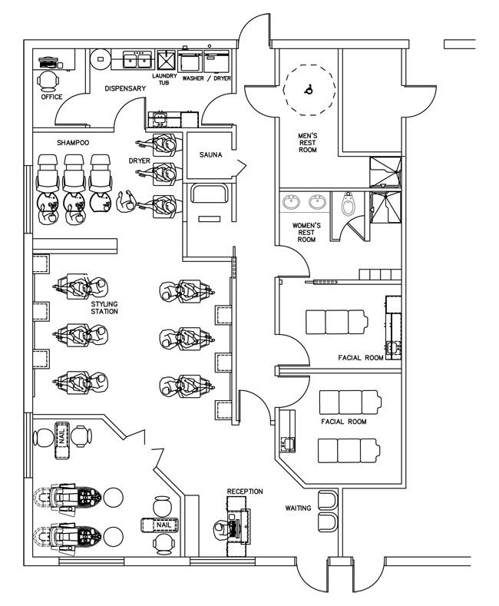
Figure 1: Floor plan of The Crawls Beauty & Spa
Job description
There will be different jobs including haircuts, styling, massaging, therapists, and trainers. Stylists will be working in the salon attending to both men and women. In the spa section, there will be therapists who focus on improving mental and physical wellness. The health club will focus on offering physical training, cardiovascular fitness, and wellness.

